Name : Kirtesh Satish Admute
Roll No. : 258039
PRN : 250841220082
Module : DBT

Following are the tables:
BRANCH (BID INTEGER, BRNAME CHAR (30), BRCITY CHAR (10))
CUSTOMER (CNO INTEGER, CNAME CHAR (20), CADDR CHAR (35), CITY
CHAR(20))
LOAN_APPLICATION (LNO INTEGER, LAMTREQUIRED MONEY, LAMTAPPROVED
MONEY, L_DATE DATE)
The relationship is as follows:
BRANCH, CUSTOMER, LOAN_APPLICATION are related with ternary relationship.
TERNARY (BID INTEGER, CNO INTEGER, LNO INTEGER).

Solve the Queries
1. Find the names of the customers for the “Aundh” branch.
select distinct c.cname
from customer1 c
join ternary t on c.cno = t.cno
join branch b on t.bid = b.bid
where b.brname = 'aundh';
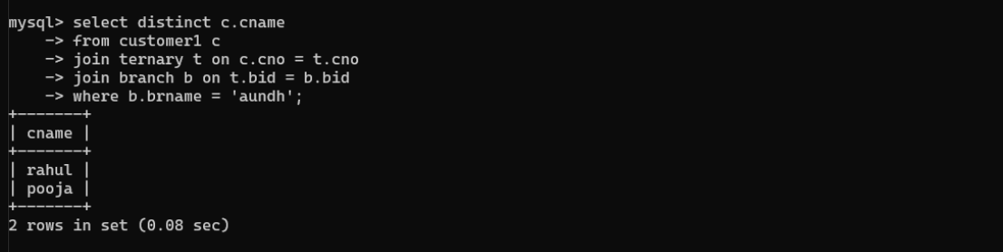

2. List the names of the customers who have received loan less than their requirement.
select distinct c.cname
from customer1 c
join ternary t on c.cno = t.cno
join loan_application l on t.lno = l.lno
where l.lamtapproved < l.lamtrequired;
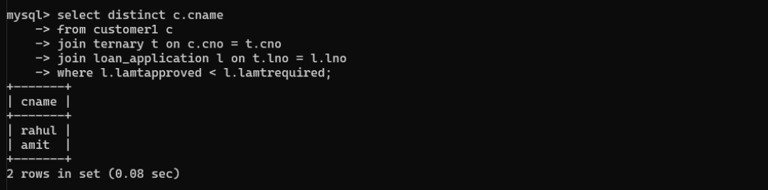

3. Find the maximum loan amount approved.
select max(lamtapproved) as max_loan_approved
from loan_application;
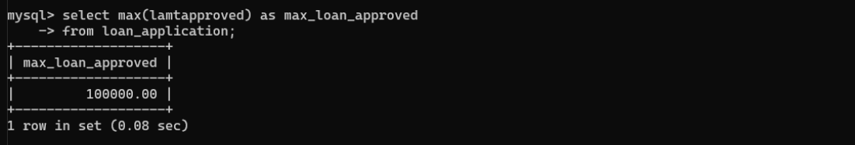

4. Find out the total loan amount sanctioned by “Deccan “branch.
select sum(l.lamtapproved) as total_sanctioned
from loan_application l
join ternary t on l.lno = t.lno
join branch b on t.bid = b.bid
where b.brname = 'deccan';
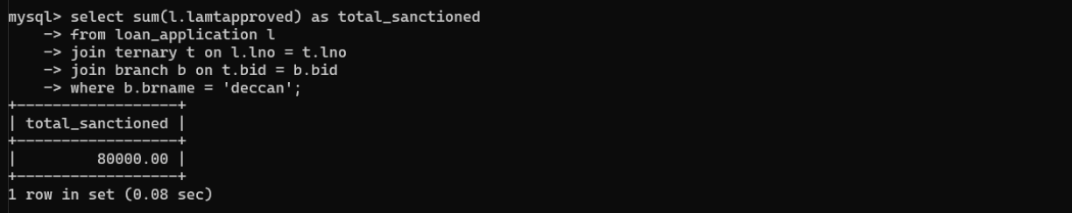

5. Count the number of loan applications received by “M.G.ROAD” branch.
select count(*) as loan_app_count
from loan_application l
join ternary t on l.lno = t.lno
join branch b on t.bid = b.bid
where b.brname = 'm.g.road';
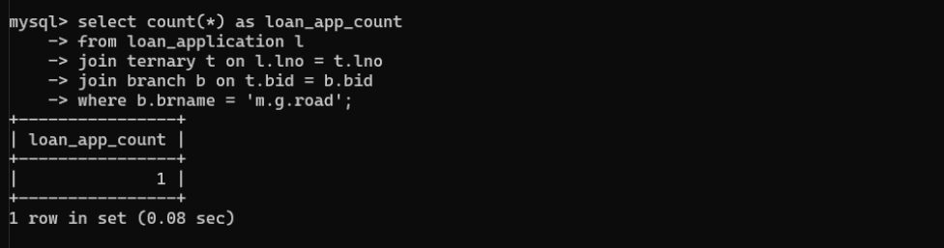

6. List the names of the customer along with the branch names who have applied for
loan in the month of September.
select distinct c.cname, b.brname
from customer1 c
join ternary t on c.cno = t.cno
join branch b on t.bid = b.bid
join loan_application l on t.lno = l.lno
where month(l.l_date) = 9;
